Project Report

1.Abstract:
The project titled Heritage Treasures: An In-Depth Analysis of UNESCO World Heritage Sites focuses on transforming raw UNESCO heritage data into meaningful visual insights using Tableau. The system provides interactive dashboards and storyboards that analyze global distribution, category classification (Cultural, Natural, Mixed), regional comparisons, and year-wise trends of heritage sites. The objective is to centralize heritage data into a structured analytical platform that enables researchers, educators, and policy makers to make informed decisions based on visual insights.
2. Introduction:
UNESCO World Heritage Sites represent globally significant cultural and natural landmarks. However, the available data is mostly presented in static reports and raw datasets, which makes interpretation difficult. This project addresses the need for an interactive analytical platform that enables comparative and trend-based analysis. By using Tableau for visualization and a web-based interface for presentation, the system simplifies complex heritage data into user-friendly dashboards.
3. Problem Statement:
Researchers and policy makers lack a centralized, interactive system to analyze UNESCO World Heritage Sites data effectively. Heritage information is scattered across reports and datasets, making it difficult to compare country-wise distribution, regional performance, category classification, and growth trends. This results in time-consuming manual analysis and limited data-driven insights.
Problem Statement Template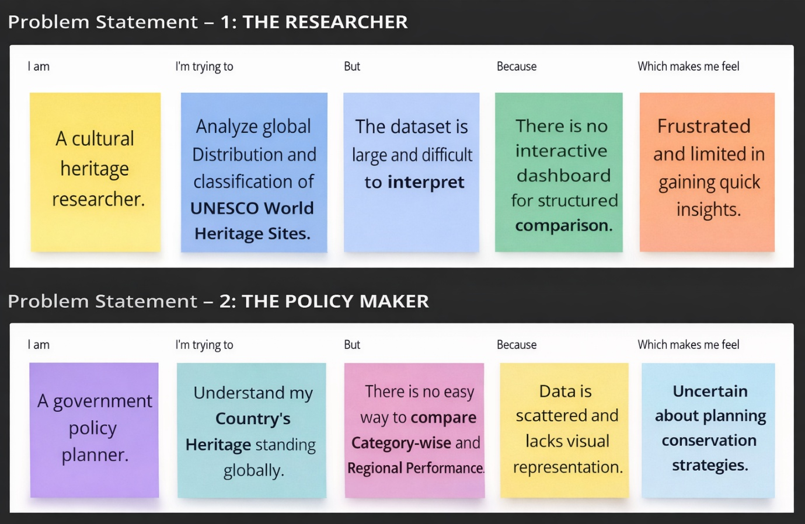
Section | Problem Statement – 1: THE RESEARCHER | Problem Statement – 2: THE POLICY MAKER
I am | A cultural heritage researcher. | A government policy planner.
I’m trying to | Analyze global distribution and classification of UNESCO World Heritage Sites. | Understand my country's heritage standing globally.
But | The dataset is large and difficult to interpret in raw format. | There is no easy way to compare category-wise and regional performance.
Because | There is no interactive dashboard for structured comparison. | Data is scattered and lacks visual representation.
Which makes me feel | Frustrated and limited in gaining quick insights. | Uncertain about planning conservation strategies.

4. Project Planning:
The project was executed using a sprint-based approach divided into three phases: data preparation, visualization development, and deployment/testing. Each sprint included defined tasks such as dataset collection, preprocessing, dashboard creation, story development, and integration. Story points and velocity were calculated to ensure timely completion.
Product Backlog, Sprint Schedule, and Estimation (4 Marks)
Sprint | Functional Requirement (Epic) | User Story No | User Story / Task | Story Points | Priority | Team Member
Sprint-1 | Data Collection | USN-1 | Download UNESCO World Heritage Sites dataset (2019) | 3 | High | Team Member
Sprint-1 | Data Understanding | USN-2 | Analyse dataset attributes (Country, Category, Year, Region) | 3 | High | Team Member
Sprint-1 | Database Setup | USN-3 | Import dataset into Tableau data source | 4 | High | Team Member
Sprint-1 | Tableau Connection | USN-4 | Connect Tableau to dataset | 4 | High | Team Member
Sprint-1 | Data Preparation | USN-5 | Clean missing values & standardize country names | 6 | High | Team Member

Project Tracker, Velocity & Burndown Chart:
Sprint | Functional Requirement (Epic) | User Story No | User Story / Task | Story Points | Priority
Sprint-2 | Data Visualization | USN-6 | Create charts (Map, Bar Chart, Trend Line) | 5 | High
Sprint-2 | Dashboard Creation | USN-7 | Design Global Overview Dashboard | 5 | High
Sprint-2 | Story Creation | USN-8 | Create UNESCO analytics Storyboard | 3 | High
Sprint-2 | Publishing | USN-9 | Publish dashboard to Tableau Public | 3 | High
Sprint-2 | Website Integration | USN-10 | Embed dashboard into web interface | 4 | High

Sprint-3 – Web & Testing Phase
Sprint | Functional Requirement (Epic) | User Story No | User Story / Task | Story Points | Priority
Sprint-3 | Website Navigation | USN-11 | Develop project sections (Home, Dashboard1, Dashboard2, Story) | 4 | High
Sprint-3 | Contact Form | USN-12 | Implement contact/feedback form | 4 | High
Sprint-3 | Responsive Design | USN-13 | Make website mobile responsive | 5 | Medium
Sprint-3 | Testing | USN-14 | Cross-browser dashboard testing | 3 | Medium
Sprint-3 | Final Review | USN-15 | Final deployment & bug fixing | 4 | High

Project Tracker, Velocity & Burndown Chart

Sprint | Total Story Points | Duration | Sprint Start | Sprint End (Planned) | Story Points Completed | Release Date
Sprint-1 | 20 | 7 Days | 28 Jan 2026 | 03 Feb 2026 | 20 | 03 Feb 2026
Sprint-2 | 20 | 7 Days | 04 Feb 2026 | 10 Feb 2026 | 20 | 10 Feb 2026
Sprint-3 | 20 | 7 Days | 11 Feb 2026 | 14 Feb 2026 | 20 | 14 Feb 2026

AV = Sprint duration/velocity =20/7= 2.85 ~ 3 story points per day

5. Brainstorming and Ideation:
During the ideation phase, the team identified the lack of structured heritage data analysis as the core problem. Multiple ideas were generated, including global mapping, category comparison charts, and trend analysis dashboards. After prioritization, the final idea selected was to develop a Tableau-based analytical dashboard system that integrates map views, comparative analysis, and storytelling features.
Empathy Map Canvas:
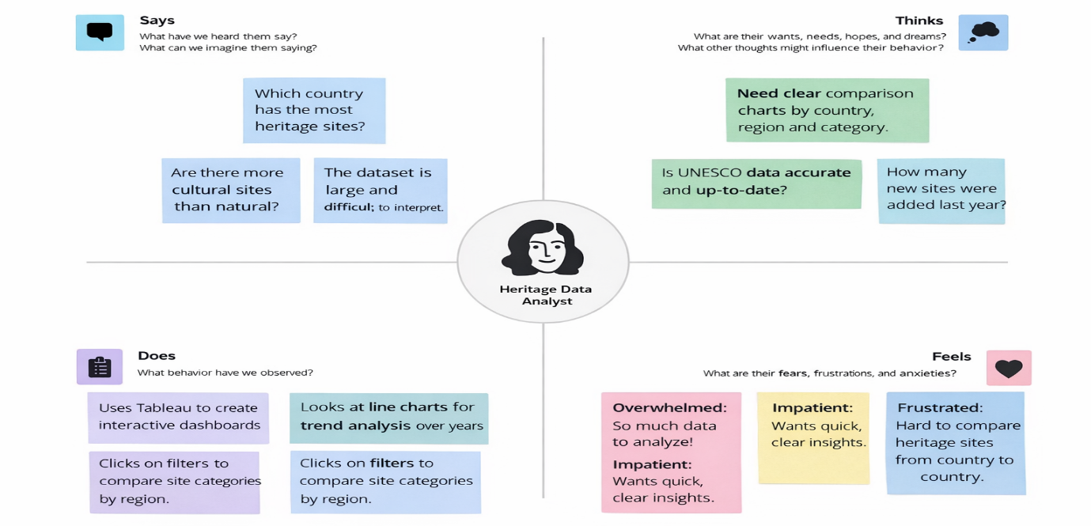

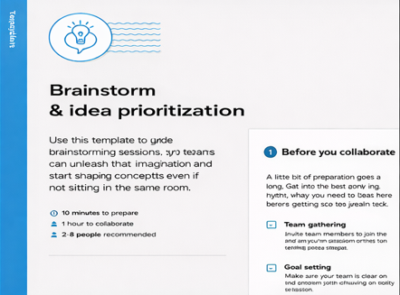
Step-1: Team Gathering, Collaboration and Select the Problem Statements

Step-2: Brainstorm, Idea Listing and Grouping
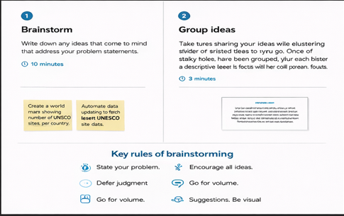
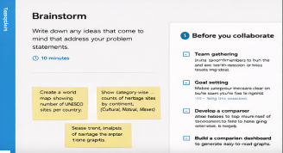
Step-3: Idea Prioritization
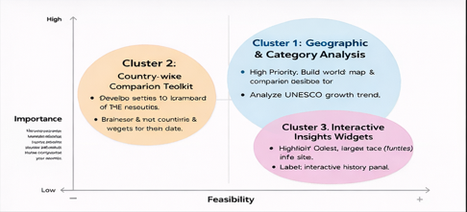

6. Customer Journey Map:
The user journey begins with discovering the website and understanding the project overview. The user then explores interactive dashboards to view global heritage distribution. Through filtering options such as country, region, and category, the user analyzes trends and comparisons. Finally, the storyboard summarizes insights, enabling informed decision-making and knowledge gain.
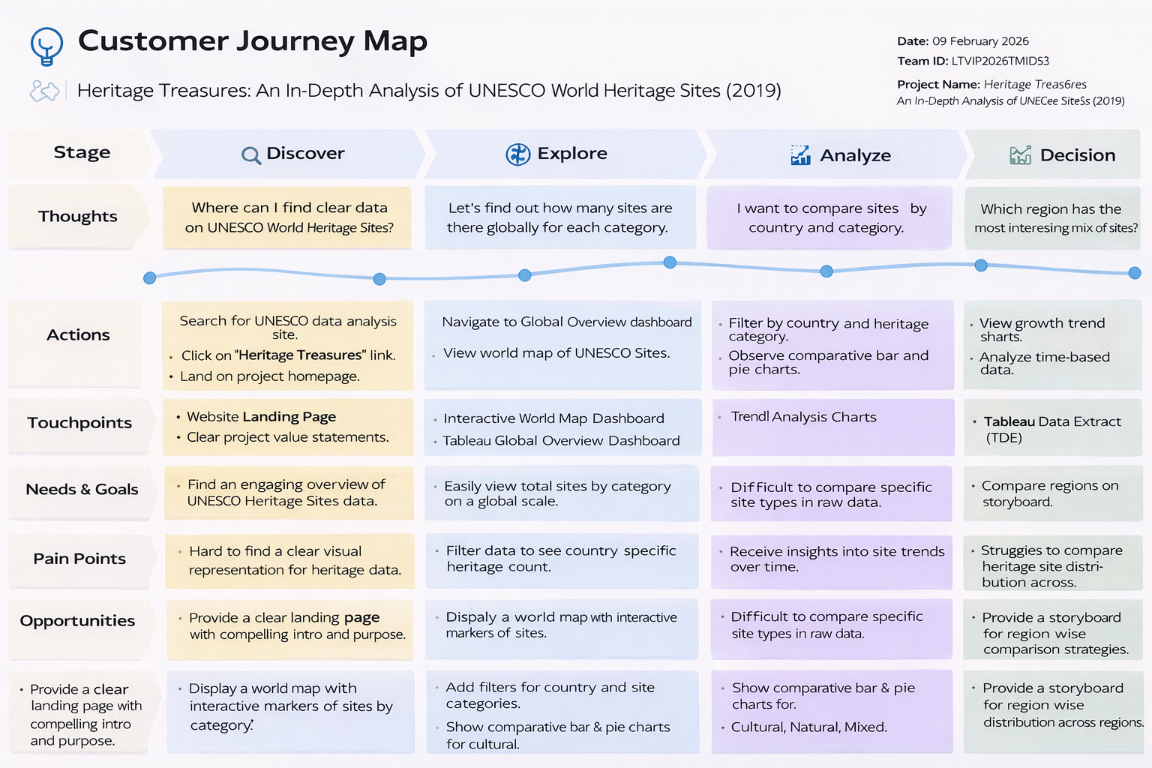

7. Requirement Analysis:
7.1 Functional Requirements
The system allows users to access the website, view interactive dashboards, apply filters, and explore storyboards. Administrators can upload and manage the UNESCO dataset and update dashboard visuals. The system supports dynamic filtering by country, category, region, and year.
FR No | Functional Requirement | Sub Requirement
FR-1 | View Website | Access Home, About, Team & Contact sections
FR-2 | View UNESCO Dashboard | Load Global Overview Dashboard  Display interactive map & charts  Enable filtering by country & category
FR-3 | View Heritage Story | Load Tableau Story  Navigate between story insights
FR-4 | Contact Form | Submit feedback  Validate required fields
FR-5 | Admin Data Management | Upload UNESCO dataset  Update dashboards  Publish dashboards

7.2 Non-Functional Requirements
The platform ensures usability, reliability, performance, availability, scalability, and security. Dashboards must load within 3–5 seconds and be accessible 24/7 via web browsers. The system should be responsive and easy to navigate.
NFR No | Requirement | Description
NFR-1 | Usability | Easy-to-navigate, user-friendly interface
NFR-2 | Security | Secure embedding of Tableau dashboards
NFR-3 | Reliability | Dashboards load without failure
NFR-4 | Performance | Website loads within 3–5 seconds
NFR-5 | Availability | Available 24/7 online
NFR-6 | Scalability | Future datasets and dashboards can be added

8. Technology Stack:
The project uses Tableau Desktop for data visualization and Tableau Public for publishing dashboards. The web interface is developed using HTML, CSS, JavaScript, and Bootstrap. The UNESCO dataset (2019) is stored and processed within the Tableau environment. The architecture supports modular expansion for future datasets.
Table-1: Components & Technologies:

Component | Description | Technology
User Interface | Web interface for dashboard & story viewing | HTML, CSS, Bootstrap 5
Dashboard Integration | Embed UNESCO Dashboard | JavaScript, Tableau Embed API
Story Integration | Embed Tableau Story | Tableau Public
Dataset Storage | UNESCO Dataset 2019 stored in Tableau | Tableau Data Extract
Hosting | Website hosting | GitHub Pages / Local Hosting
Dashboard Hosting | Dashboard published online | Tableau Public Cloud

Table-2: Application Characteristics:
Characteristic | Description | Technology
Open-Source Frameworks | Frontend frameworks | HTML5, CSS3, Bootstrap
Security | Secure dashboard embedding | HTTPS
Scalable Architecture | Modular structure | Cloud-based deployment
Availability | 24/7 Dashboard access | Tableau Public
Performance | Optimized UI & loading | Bootstrap Grid

9. Solution Architecture:
The architecture consists of the UNESCO dataset as the primary data source, which is imported into Tableau for cleaning and modeling. Calculated fields and filters are applied to generate dashboards. These dashboards are published to Tableau Public and embedded into a web interface. Users interact with the dashboards through filters, maps, and story navigation components.
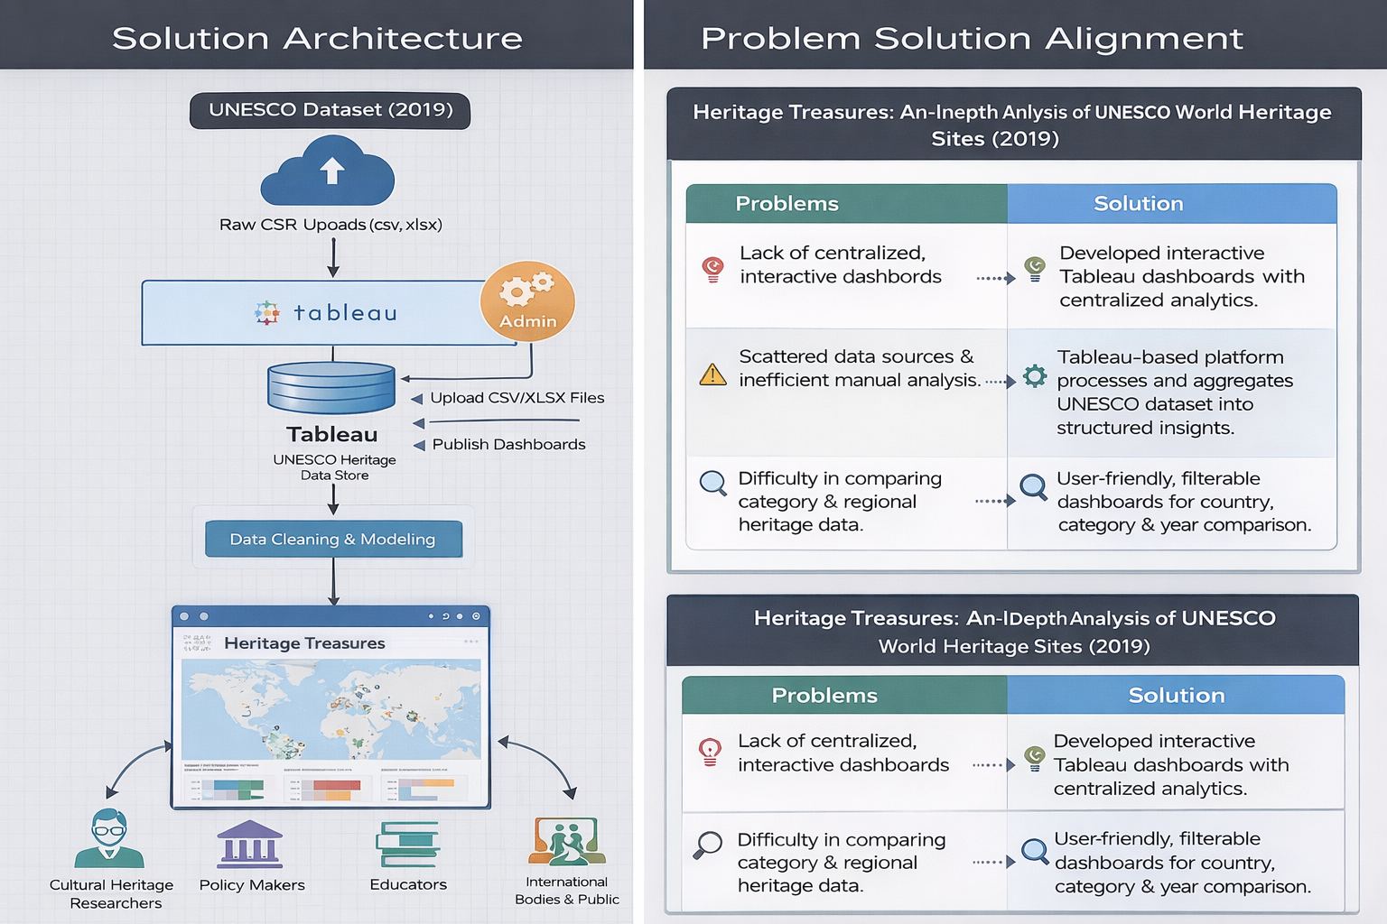

10. Data Flow Diagram:
10.1 Level 0 DFD
The Level 0 DFD provides a high-level overview of the system. The researcher interacts with the Heritage Analytics System, which retrieves data from the UNESCO dataset and generates comparative dashboards and trend insights.
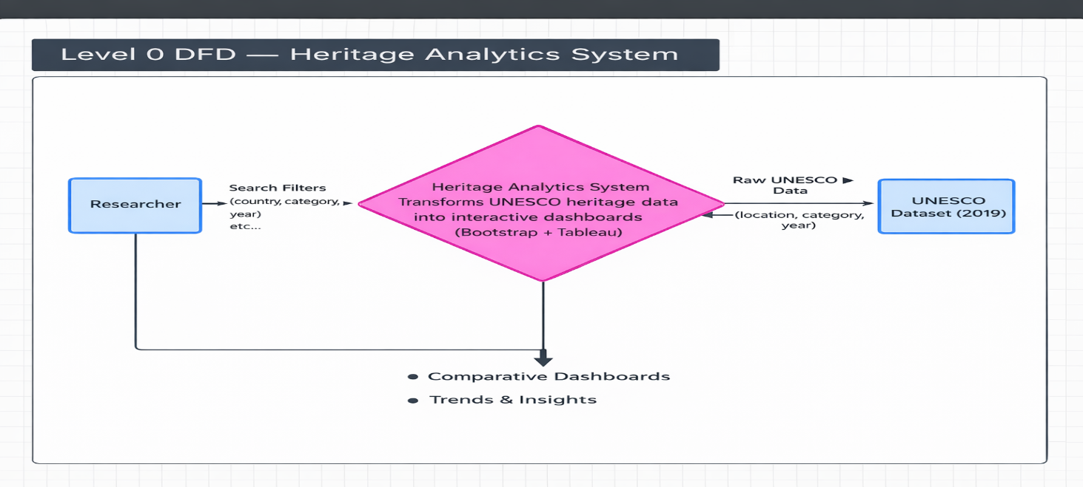
10.2 Level 1 DFD
The Level 1 DFD explains detailed processes such as filter submission, data preprocessing, dashboard generation, and publishing. It also includes administrative functions for dataset upload and maintenance.
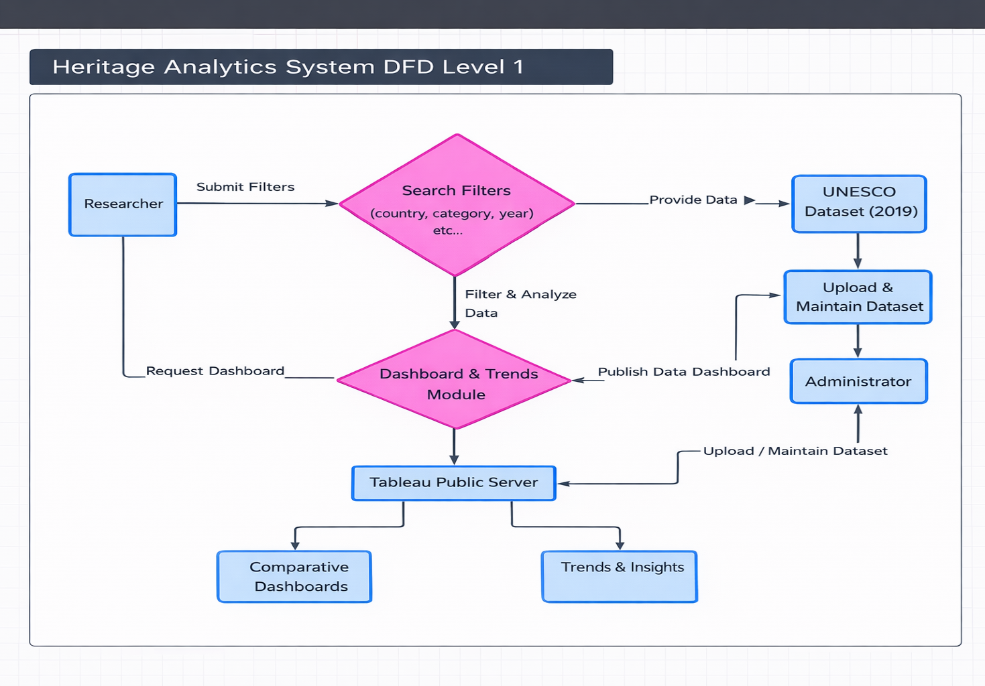

User Stories
Use the below template to list all the user stories for the product.
User Type | Functional Requirement | USN | User Story | Acceptance Criteria | Priority | Release
Researcher (Web user) | Website Access | USN-1 | As a user, I can access the Heritage Treasures website from any browser. | Website loads successfully | High | Sprint-1
Researcher | View Dashboard | USN-2 | As a user, I can view the UNESCO Global Overview Dashboard. | Dashboard loads correctly | High | Sprint-1
Researcher | View Story | USN-3 | As a user, I can explore the Heritage Analytics Story. | Story navigation works | High | Sprint-1
Researcher | Navigation | USN-4 | As a user, I can navigate between Home, About, Dashboard, Story, Team & Contact sections. | Navigation works smoothly | High | Sprint-1
Researcher | Contact Form | USN-5 | As a user, I can submit feedback through the contact form. | Form validation works | High | Sprint-1
Researcher | Responsive Design | USN-6 | As a user, I can access the website on mobile and desktop. | Layout responsive | Medium | Sprint-2
Administrator | Data Upload | USN-7 | As an admin, I can upload UNESCO dataset to Tableau. | Dataset uploads successfully | High | Sprint-1
Administrator | Dashboard Update | USN-8 | As an admin, I can update dashboard visuals. | Updates reflected instantly | High | Sprint-1
Administrator | Publish Dashboard | USN-9 | As an admin, I can publish dashboard to Tableau Public. | Dashboard embed works | High | Sprint-1

11. Project Development Phase:
11.1 Data Collection:
The UNESCO World Heritage Sites (2019) dataset was downloaded in CSV/Excel format. The dataset was verified for completeness and correctness.
11.2 Data Understanding:
Column names, data types, and attribute meanings were analyzed. Analytical questions were framed to guide visualization design.
11.3 Data Preprocessing:
Duplicate records were removed, missing values handled, data types corrected, and country/category names standardized. Calculated fields such as total sites per country and year-wise trends were created.
11.4 Dashboard Development:
Two dashboards were created:
- Global Overview Dashboard (map, category distribution, top countries)
- Category & Trend Analysis Dashboard (year-wise trend, regional comparison)
11.5 Story Development:
A storyboard was created to present insights step-by-step, including global distribution, category analysis, trend insights, and regional comparisons.

12. Performance Testing:
The dataset was successfully rendered in Tableau without errors. Filters were tested for dynamic interaction. Calculated fields were validated for accuracy. Dashboards were tested for responsiveness and loading performance. Story navigation was verified to ensure smooth transitions.
S.No. | Parameter | Screenshot / Values
1 | Data Rendered | The UNESCO World Heritage Sites (2019) dataset was successfully rendered in Tableau Desktop. All fields including Site Name, Country, Region, Category (Cultural/Natural/Mixed), Year of Inscription, Latitude, and Longitude were loaded correctly without errors.  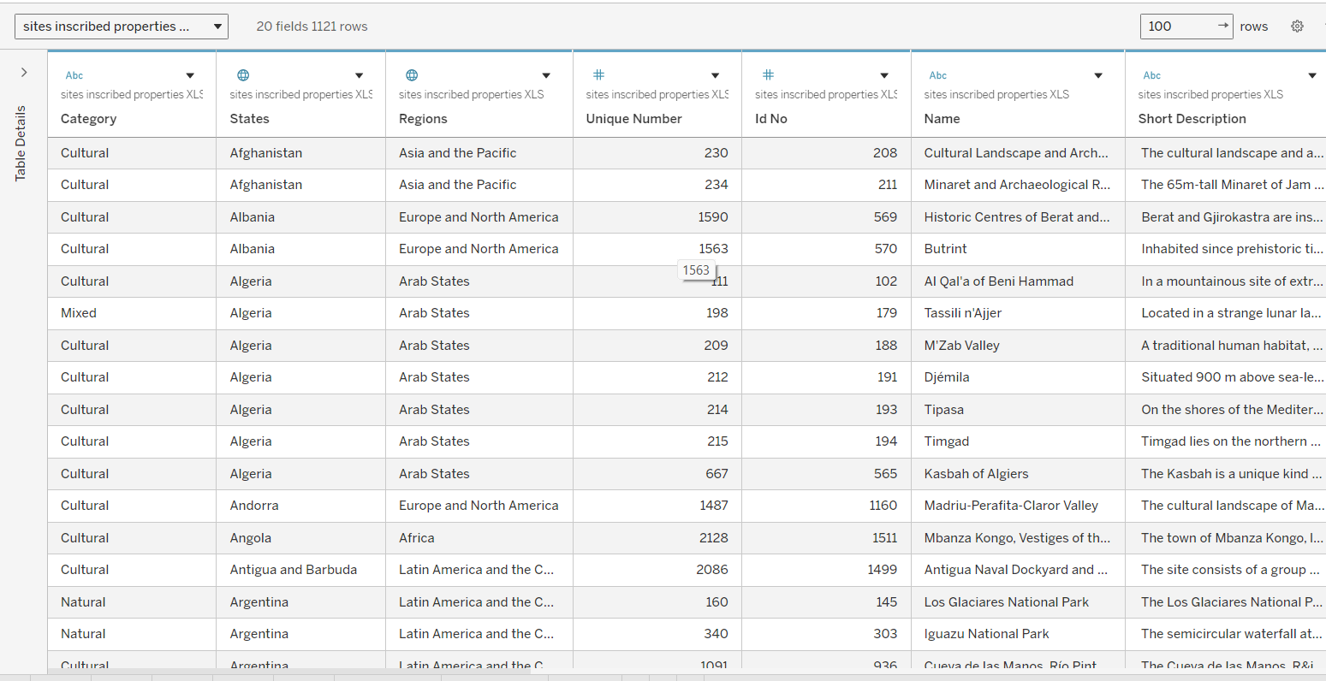
2 | Data Preprocessing | Data preprocessing was performed by handling missing values, removing duplicate site entries, correcting data types (Year, Geographic fields), and creating calculated fields. Country names and categories were standardized and unnecessary columns were removed before visualization.  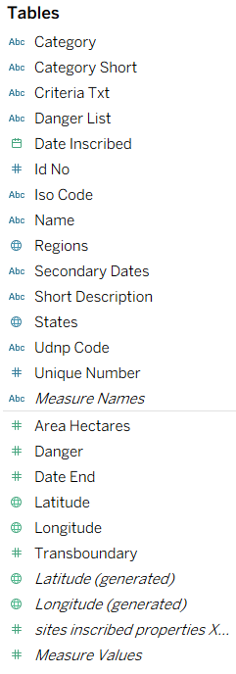
3 | Utilization of Filters | Filters such as Country, Region, Category (Cultural/Natural/Mixed), and Year of Inscription were applied to enable dynamic interaction in the dashboard.  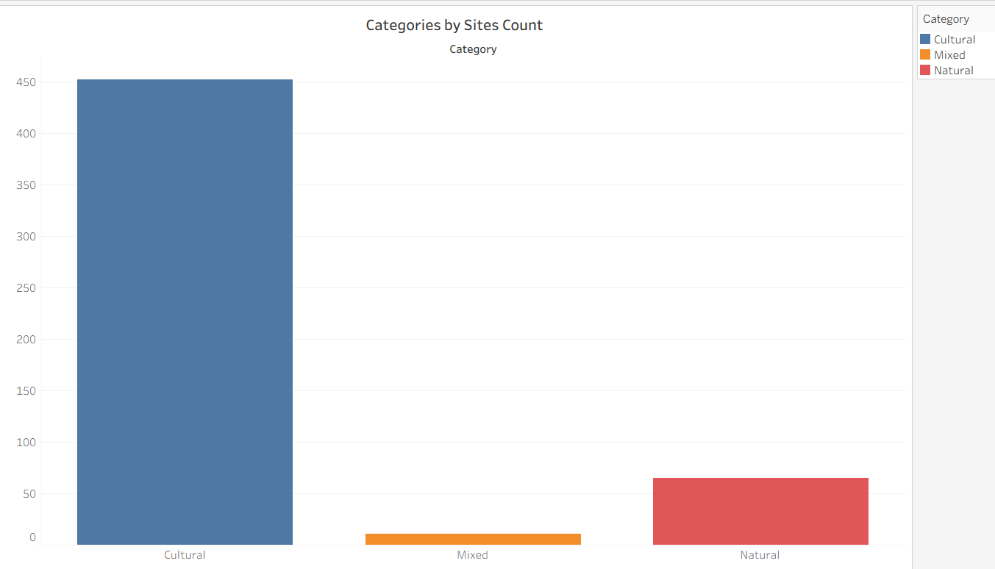
4 | Calculated Fields Used | COUNT([Site Name]) COUNT([Country]) COUNT([Category]) YEAR([Year of Inscription])  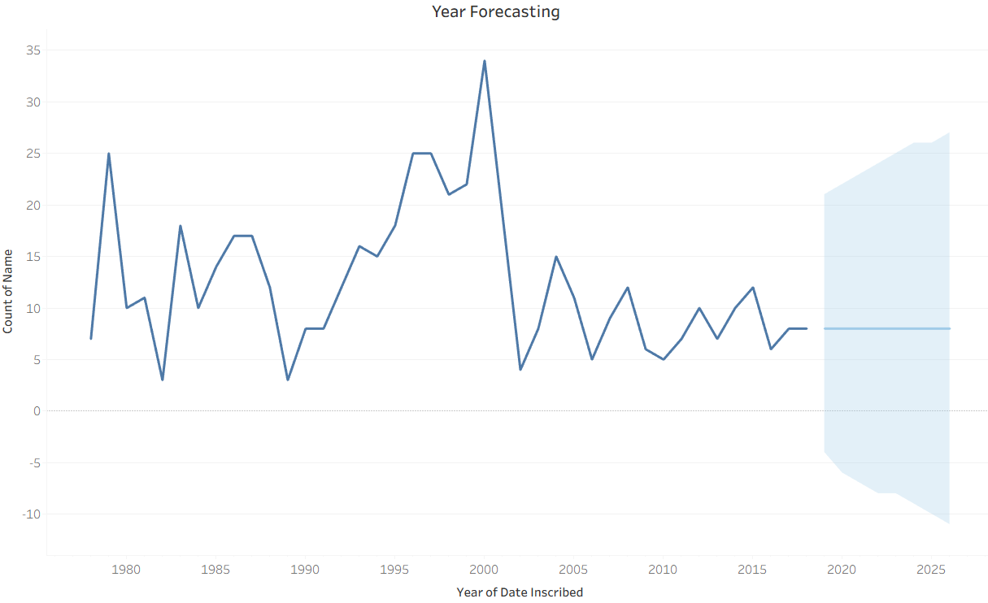
5 | Dashboard Design | 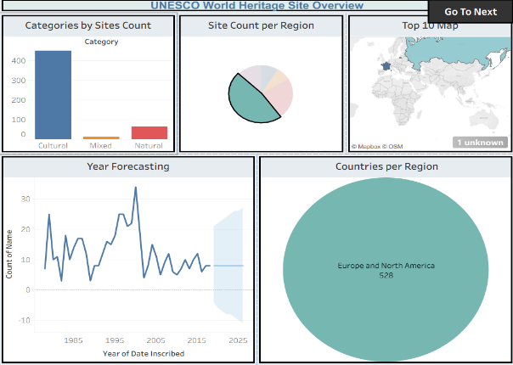  No. of Visualizations / Graphs – 5 (World Map, Category Pie Chart, Top 10 Countries Bar Chart, Year-wise Trend Line, Region Comparison Chart)  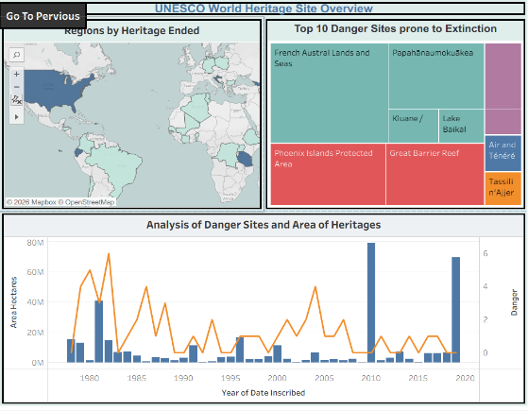
6 | Story Design | 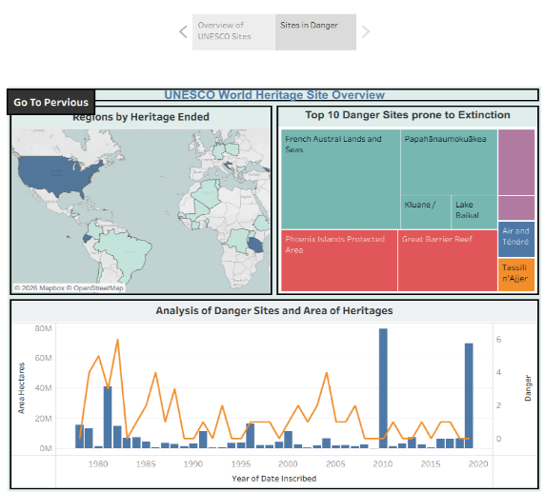  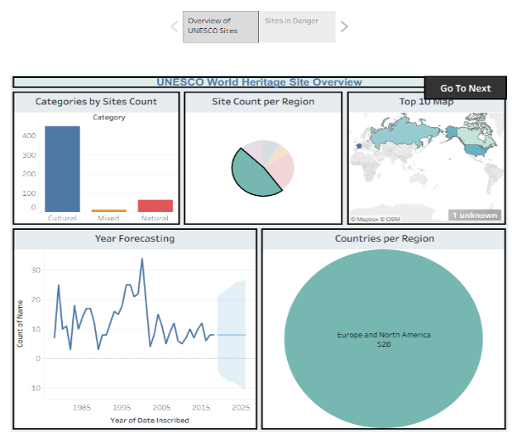  No. of Visualizations / Graphs – 4 (Global Overview, Category Analysis, Trend Analysis, Regional Comparison)

13. Result:
The analysis revealed variations in heritage site distribution across countries and regions. Cultural sites constitute a significant proportion of total heritage listings. Year-wise trends show gradual growth in site inscription over time. Regional comparisons highlight concentration differences between continents.
14. Advantages & Disadvantages:
Advantages:
- Centralized UNESCO heritage data analysis
- Interactive dashboards with filters
- Easy comparison by country, region, and category
- Clear visualization of trends and distribution
- Supports research and policy planning
- Scalable for future dataset expansion
Disadvantages :
- Limited to 2019 dataset
- Depends on internet and Tableau Public
- No predictive or advanced analytics
- Performance may slow with large datasets
- Insights depend on data accuracy
15. Conclusion:
The Heritage Treasures project successfully transforms raw UNESCO World Heritage Sites data into interactive, user-friendly dashboards. The system centralizes heritage analytics, improves data accessibility, and enhances comparative analysis. By combining Tableau visualization with a structured web interface, the project delivers meaningful insights and supports informed decision-making in heritage conservation and research.
Future Scope:
The project can be enhanced by integrating updated UNESCO datasets and adding predictive analytics for trend forecasting. Advanced visualizations such as heat maps and regional clustering can improve analysis. Future improvements may also include conservation risk monitoring, mobile application development, and AI-based insights for deeper heritage analysis.

APPENDIX
Dataset Link:
https://www.kaggle.com/datasets/ujwalkandi/unesco-world-heritage-sites/data?select=whc-sites-2019.csv
GitHub Link:

Project Demo Link:

